Nama : Aliffio Syah M

NIM : 41519120065

Mata Kuliah : Pemrograman Web Enterprise

**Tugas Pertemuan 12**

**NextJS :**

**Create bar chart to display rekap total peminjaman per buku**

**Step to Finish :**

**Create SQL Groupping (SELECT COUNT, NOT SUM)**

**Create View**

**Display Bar in new screen**

**Answer**

**Create SQL Groupping (SELECT COUNT, NOT SUM)**

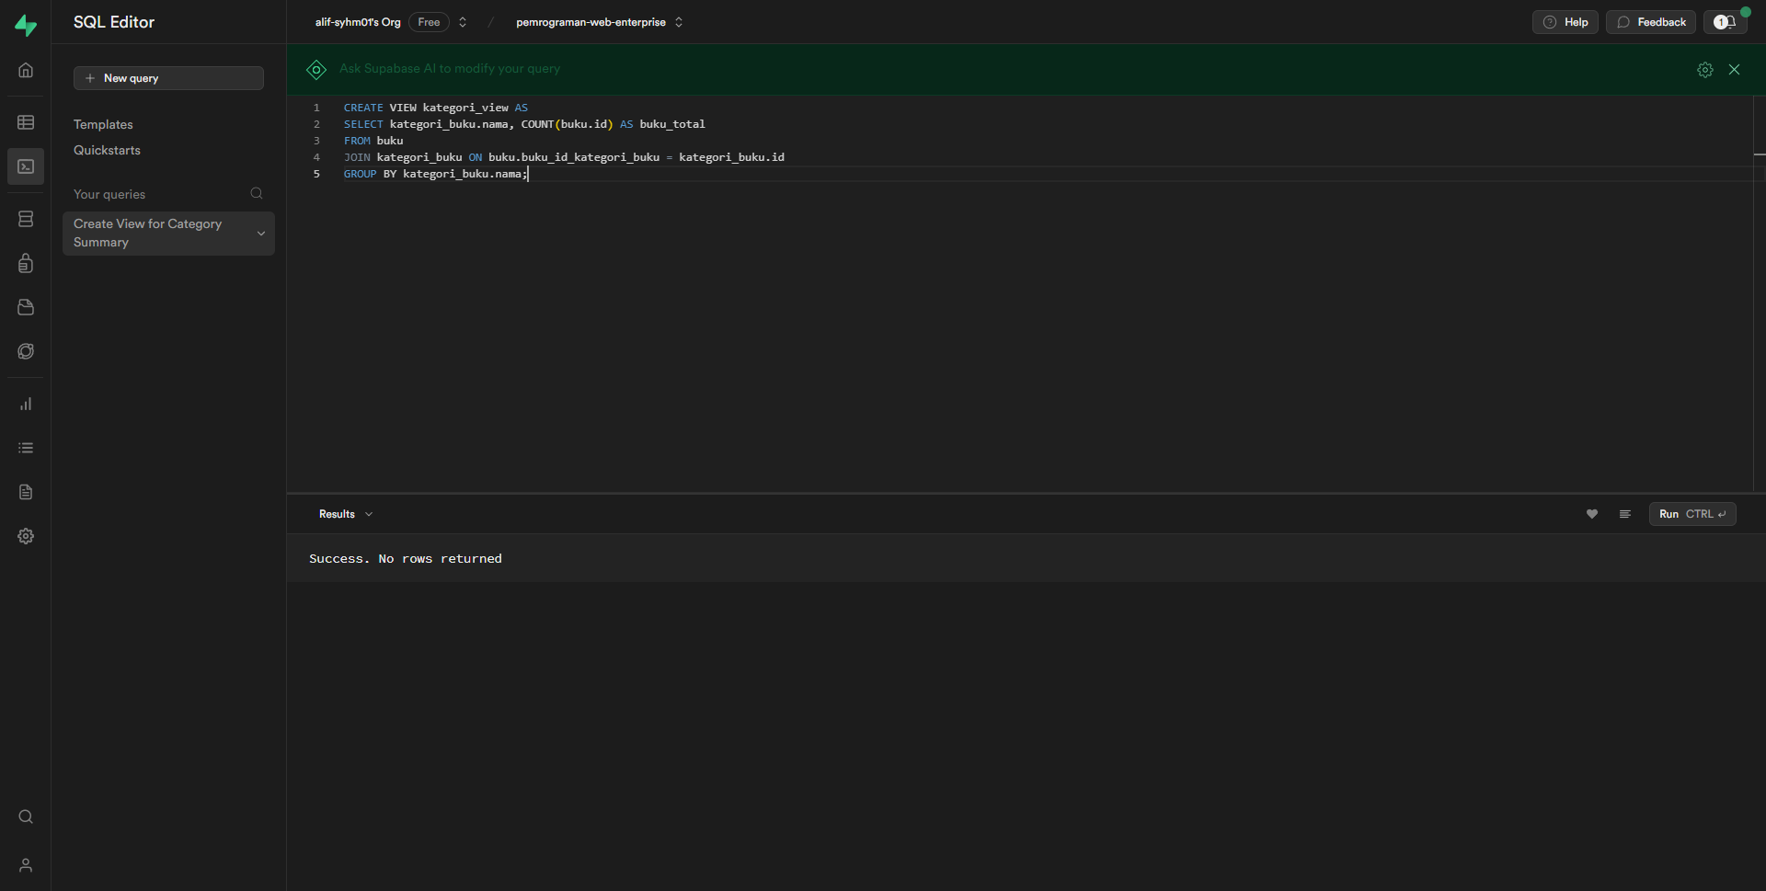

**Create View**

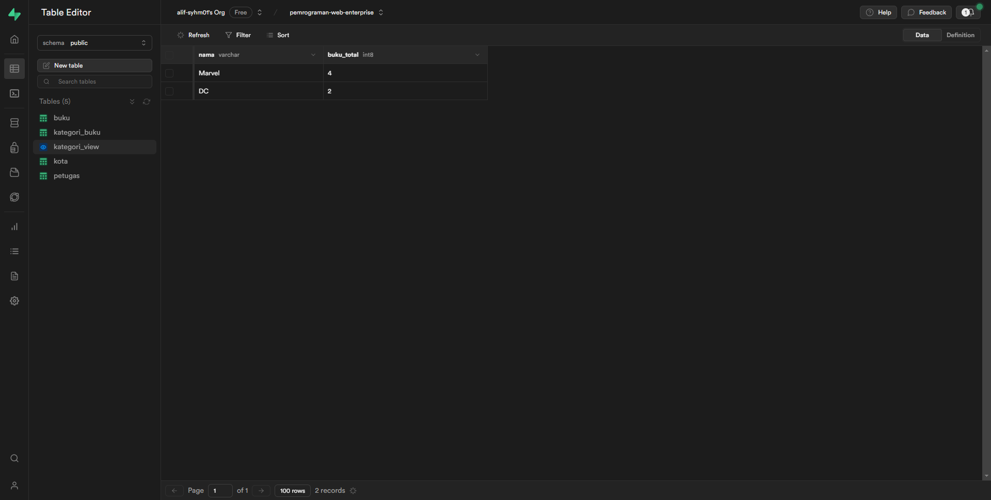

**Display Bar in new screen**

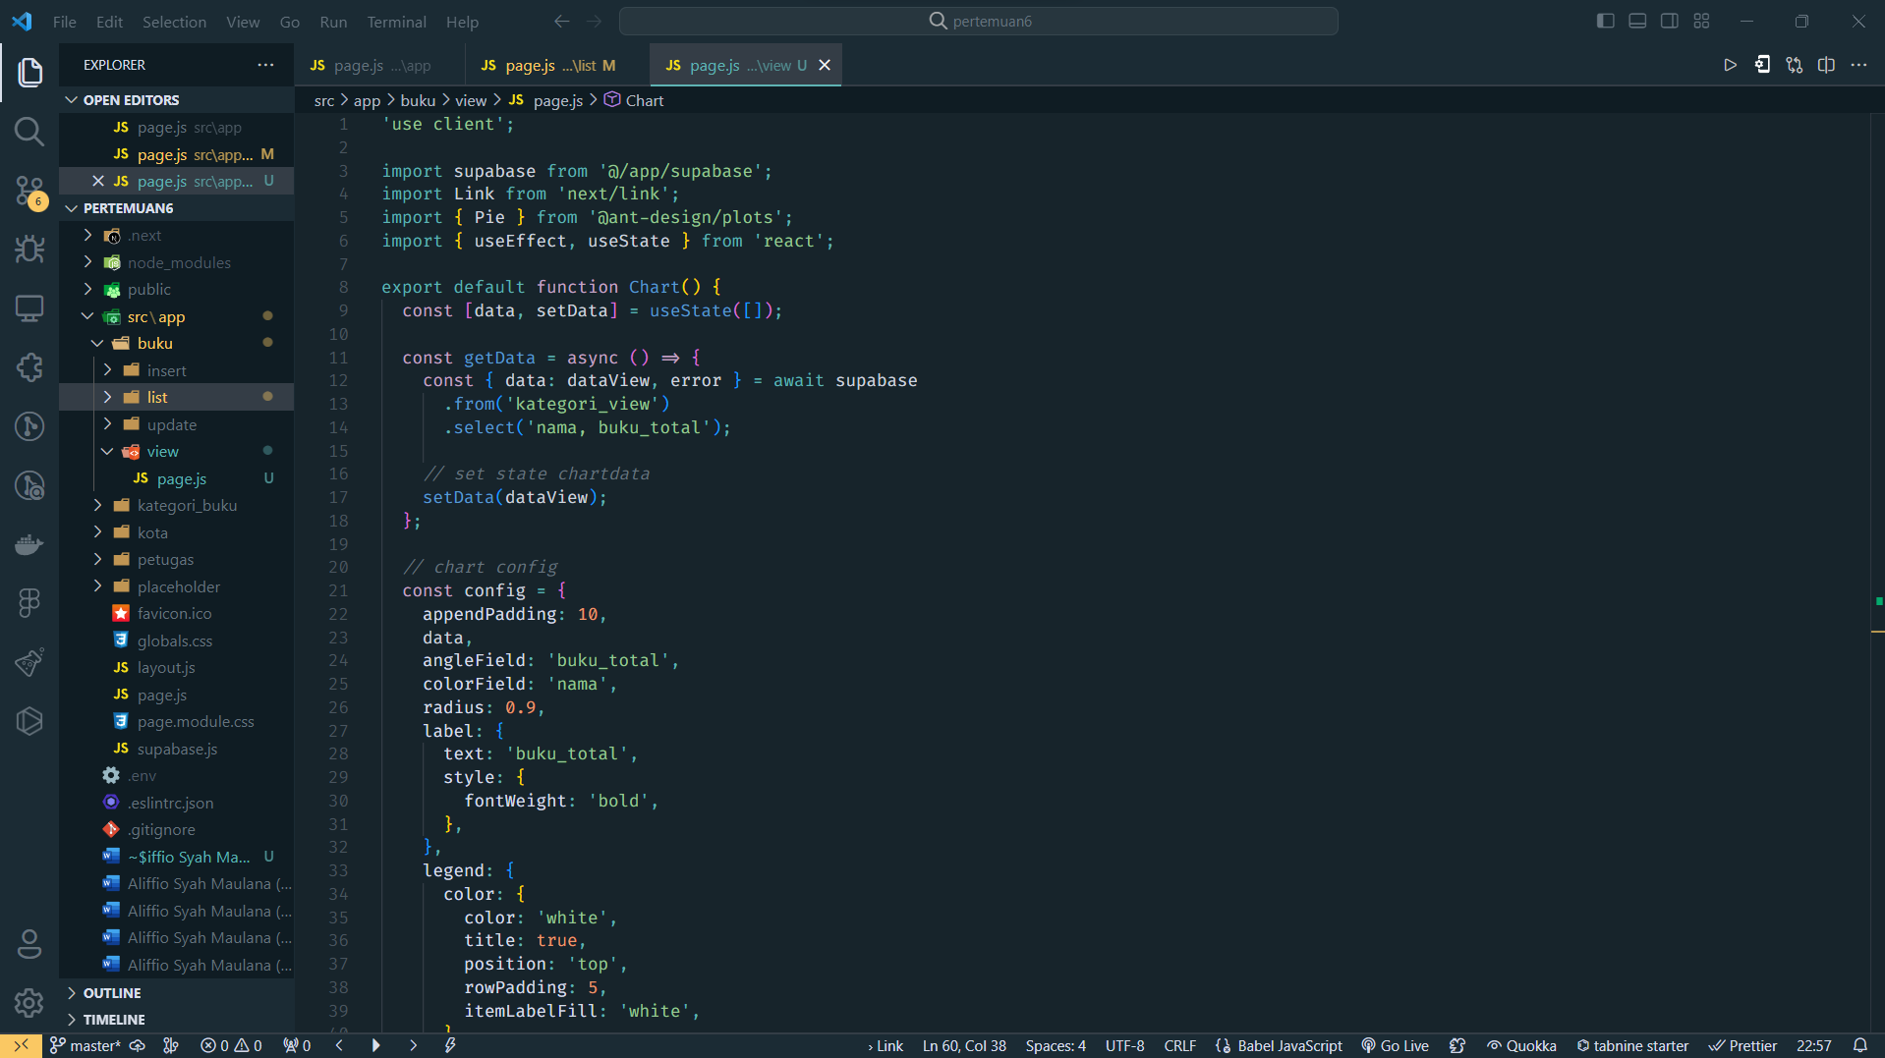

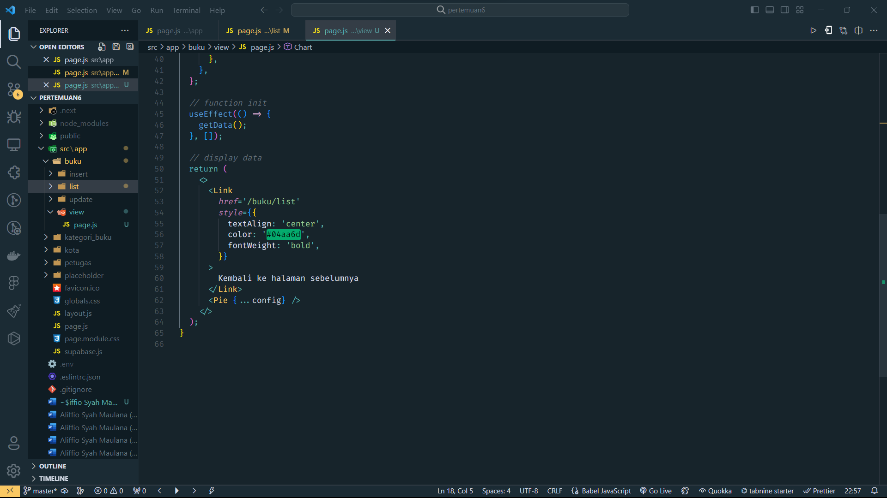

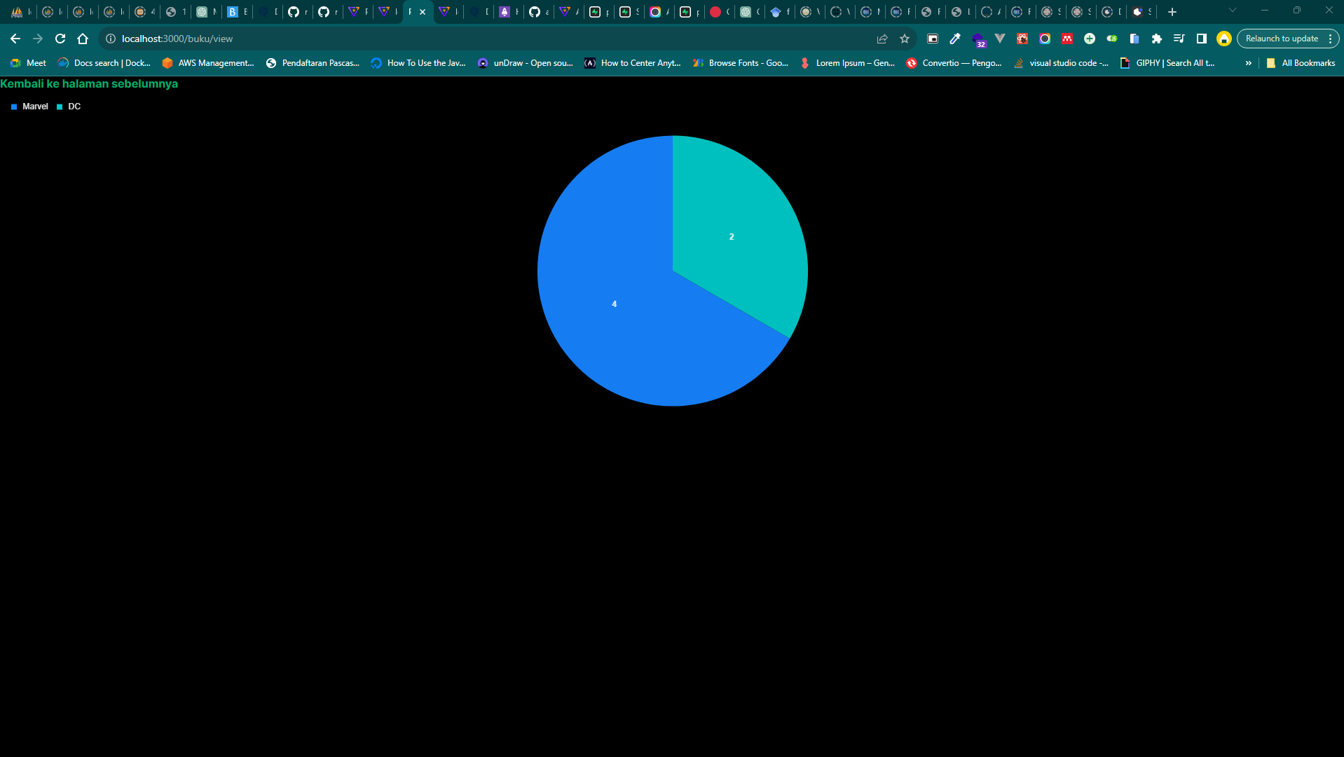

**Complete Code in Github:**

<https://github.com/alif-syhm01/pemrograman-web-enterprise-pertemuan6.git>